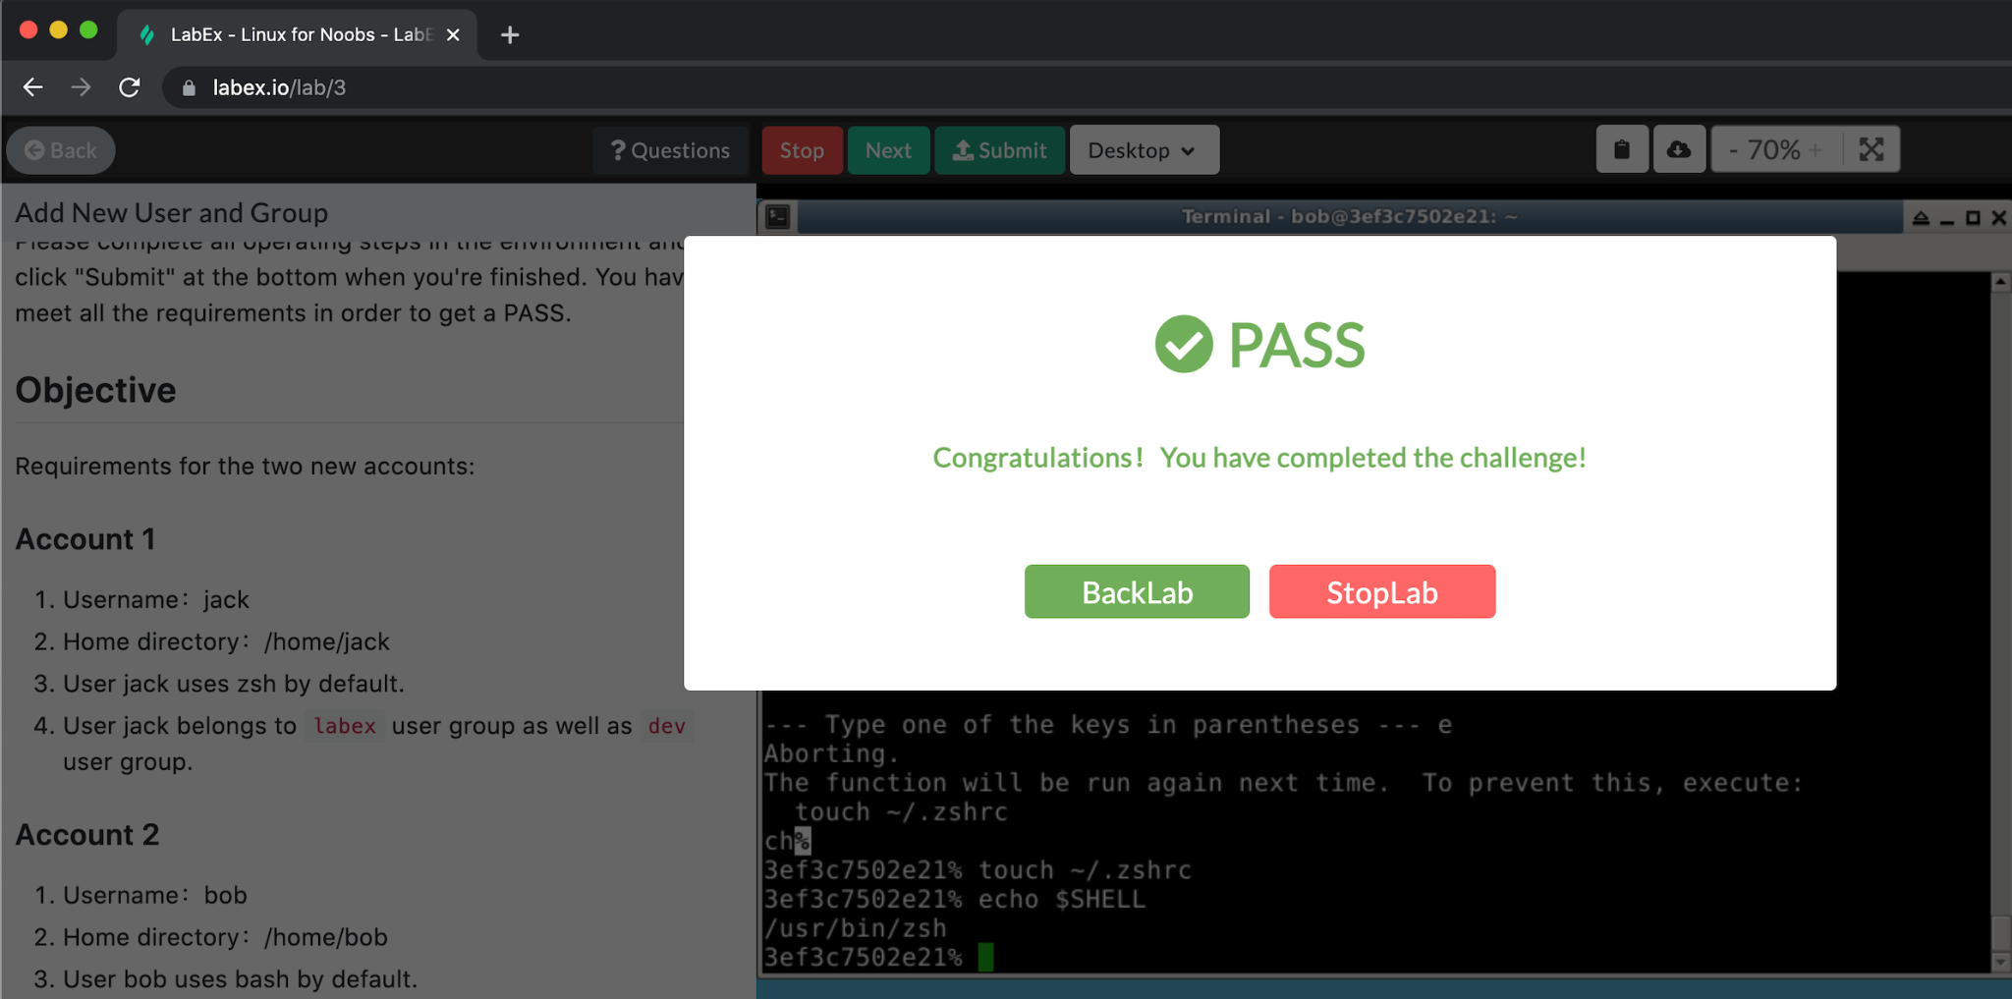**Challenge 1**: Add New User and Group

Objectives:

Create 2 accounts, ‘jack’ & ‘bob’

Their respective home directories must be /home/’their-name”

‘jack’ must belong to user groups ‘labex’ & ‘dev’

‘bob’ must belong to user groups ‘labex’ & ‘test’

‘jack’ uses zsh by default while ‘bob’ uses bash

1. sudo adduser jack; sudo adduser bob

creates the users along with their passwords and other account information

1. sudo groupadd dev; sudo groupadd test

creates two groups, ‘dev’ and ‘test’

1. sudo usermod -G dev,labex jack;

sudo usermod -G labex,test bob

adds the two accounts to the desired groups

check they are added with **optional: groups jack; groups bob**

1. a) su -l jack

*lower case L

log into jack’s account

b) echo $SHELL

determine what type of shell is default. The returned value is bash

c) chsh -s $(which zsh)

this will change the shell type. chsh(change shell) requires the path to the zsh shell, and that is determined by the ‘which’ function

1. a) su -l bob

*lower case L

log into bob’s account.

b) echo $SHELL

determine what type of shell is default. The returned value is bash. No further action required

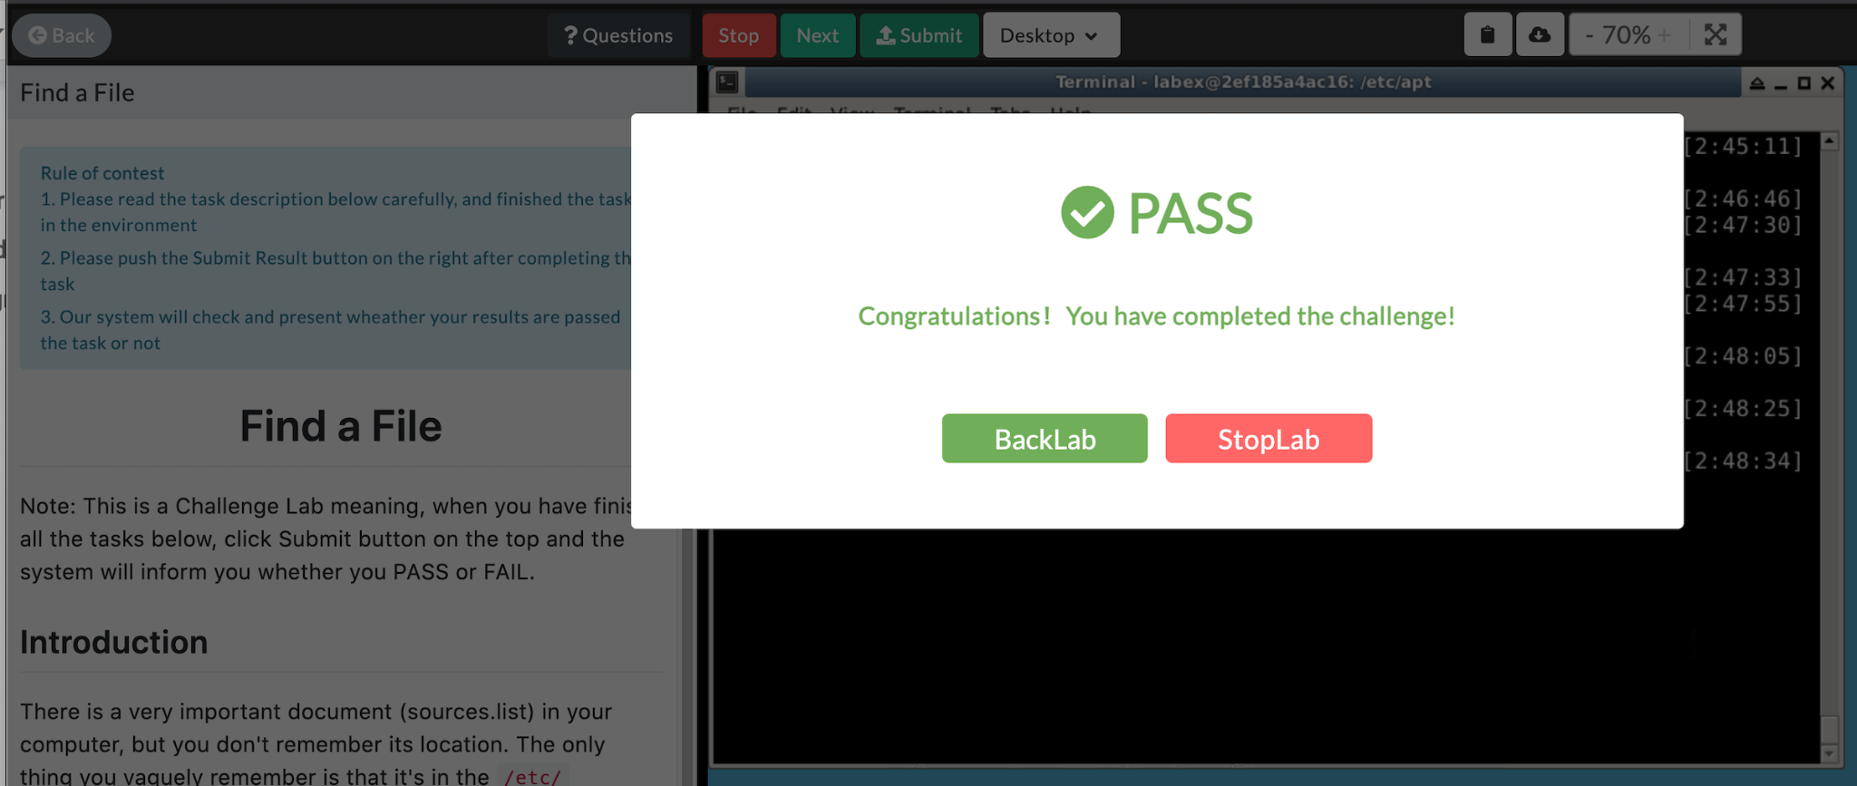

**Challenge 2**: Find a File

Objectives:

Find the file (sources.list)

Change the file owner to yourself

Set access authority so that only you can write/read this file

1. Begin by moving to the root directory, cd /, in order to search the etc folder using find etc -name “sources.list”. The output is etc/apt/sources.list
2. Change directories in order to directly access the file, cd etc/apt. List the file with an -l option to provide information on the current file permissions, ls -l sources.list (optional)
3. Change the permissions of the folder, so that only the owner can access it, sudo chmod 600 sources.list
4. Change the owner of the folder to yourself (labex), sudo chown labex sources.list

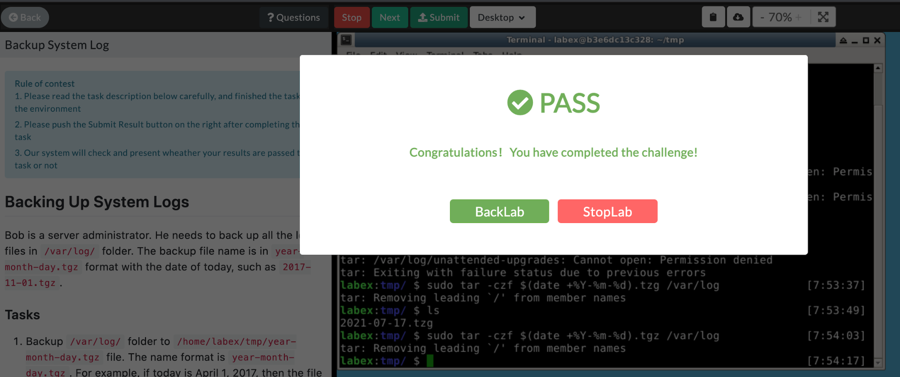**Challenge 3**: Backing Up System Logs

Objectives:

Backup /var/log/ folder to /home/labex/tmp/year-month-day.tgz file. For example, if today is April 1, 2017, then the file name is 2017-04-01.tgz

1. Begin by making the tmp directory: mkdir tmp. Move into the directory: cd tmp.
2. Execute this function: sudo tar -czf $(date +%Y-%m-%d).tgz /var/log. We require sudo because the user (labex) does not have permissions to access /var/log. The options -czf are required because: ‘c’ creates the destination file, ‘z’ compresses the target files, and ‘f’ designates the next argument to be the file name. $(date +%Y-%m-%d) gives the current date in a YYYY-MM-DD format as a single name for the file. Finally /var/log are the targeted files to be archived for backup.

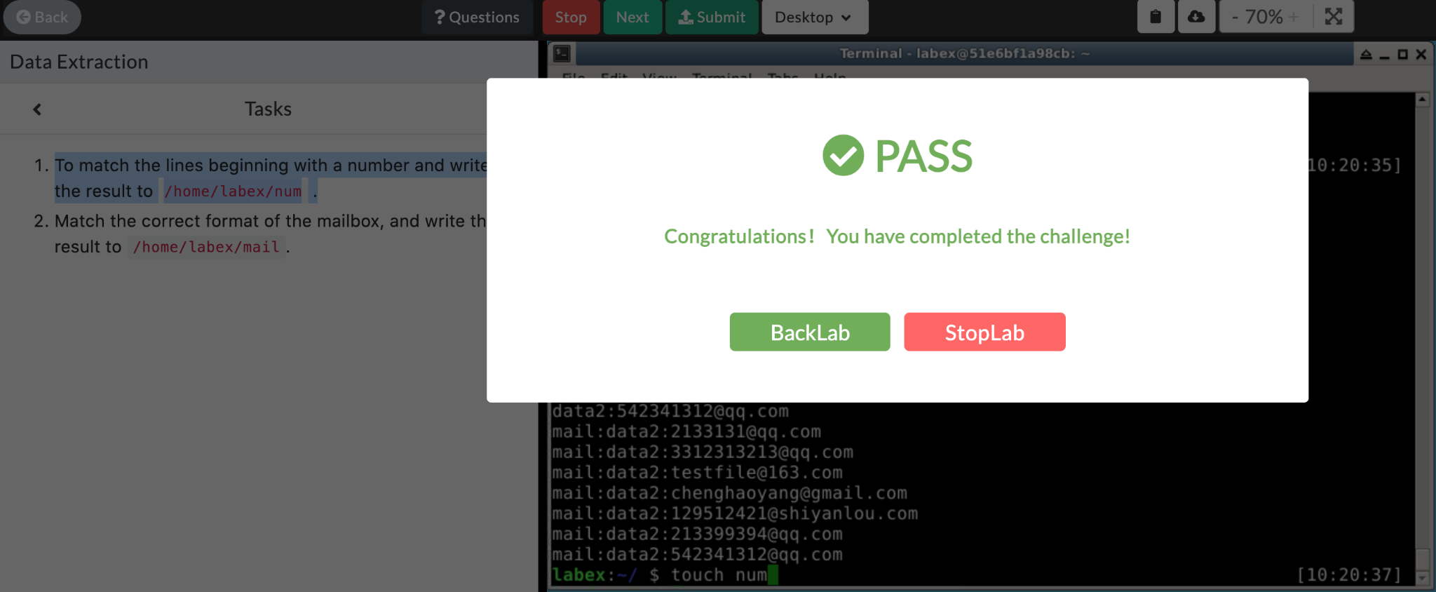**Challenge 5**: Data Extraction

Objectives:

Given a data set, find the email addresses and store them in a file /home/labex/mail, and find the lines beginning with numbers and store them in a file /home/labex/num

1. Download the data with the given command.
2. Create two files for the data to be separated into, touch mail; touch num
3. Separate the email addresses into the ‘mail’ file. grep -E “\.com” * > mail
4. Separate the numbers into the ‘num’ file. grep -E [0-9] * > num